**Screenshot**

**NUnit all test pass**

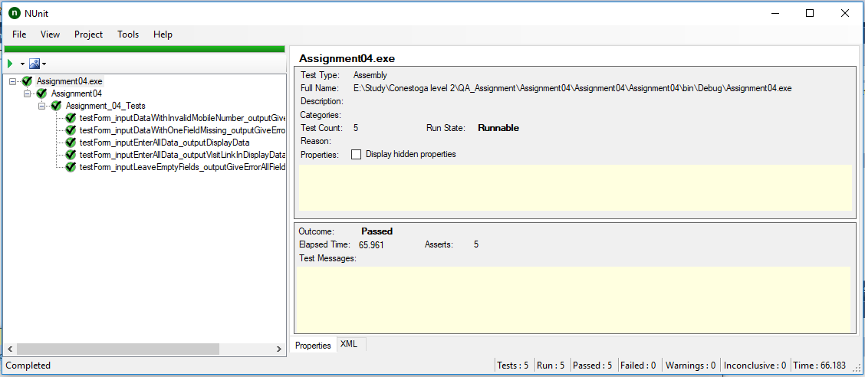

**Git Log**